***PERFORMANCE MANAGEMENT DASHBOARD***

The performance management dashboard is a useful tool to get a quick glance at how your organization, departments and individuals in those departments are staying on task within Connections Online.

This may answer questions such as: How many metrics are currently performing at expected levels or better in the finance department? Which individuals are keeping up with their dialogs? I am looking for someone to lead a new project, which one of the people that report to me does not currently have a lot of tasks they need to finish?

The example below is a sample department dashboard. There are four areas that will show data for the period you have selected if it exists. If there are no data for the selected period or if the section is unchecked in the dashboard settings, the section will not appear.

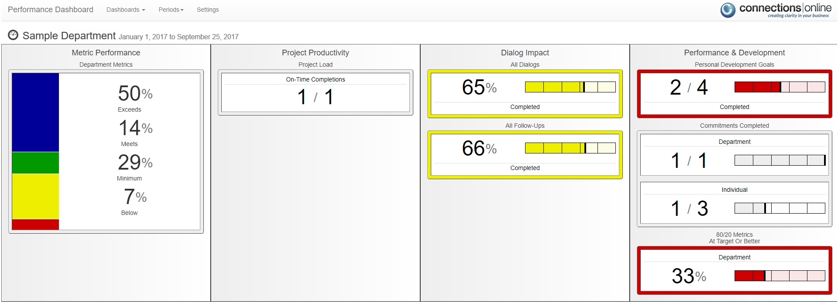

**Getting Started**

The  link in the PM section at the right side of the application will take you to the dashboard for the page you are currently on. If you are on the finance departments connection it will load the dashboard for that department. On your individual connection page, it will take you to the performance dashboard page for yourself. There are additional links and navigation options available once you are in the dashboard, this is not the only way to get to the performance dashboard for a connection.

Before the performance management dashboard can be used a Site Administrator will need to create a performance period. Use the Settings tab to create your periods and edit all the settings for the Project Management system.

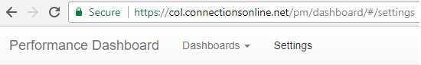

On the top of the dashboard settings page under performance periods, the  icon is used to add a new period. Also, you can select the on the left to edit an existing period or the  on the right to delete the period in that row.

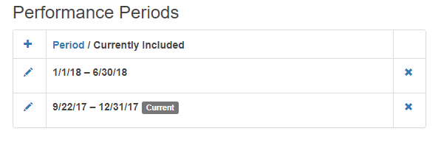

**Performance Period**

A performance period is a time span for which your organization has a cycle of tracking and analyzing business progress. A project, metric, dialog, survey, or anything else in Connections Online can only belong to one performance period. It is recommended to have a start and end date that does not overlap another performance period. Below is an example of a full year period.

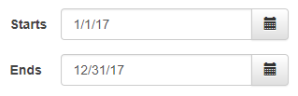

**Threshold Values**

The default threshold values are the 90%, 80% and 60% breakpoints you see below. These thresholds will set the expectations for that specific period. The top tier is colored blue and is achieved by scoring at or above the top threshold on a section. The metrics in the exceeds range will be blue, meets will be green, minimum at yellow and below minimum will be colored red.

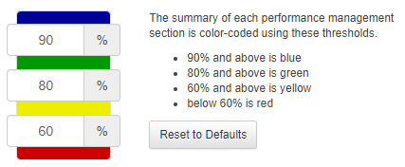

The threshold values that are set will be used in the dashboard for everyone on your site during the period. Each period can have different threshold values, section inclusions and section weights.

**Section Display & Weighting**

The last settings for the period is which sections to display in the dashboard and what weights to use for those sections on the individual performance report. Any section that is not selected will not be shown in the dashboard for that period and that section will also not be considered toward the overall score in the individual performance report. Also, if an individual does not have anything in a section for the period the score, 0, and the weight will be excluded from their overall score.

The section weights are currently only used in the individual performance report. The weights give more or less importance to a section depending on whether the weight value increases or decreases relative to the other weights. In the example below each section with a weight of 2 counts twice as much as the sections with a weight of 1. If a section has a weight of 0 then it is excluded from the overall score on the individual performance report but may still be visible in the dashboard if its checkbox is selected. The weight numbers themselves aren’t as important as their value in relation to the other weights. If all the weights are the same there essentially are no weights.

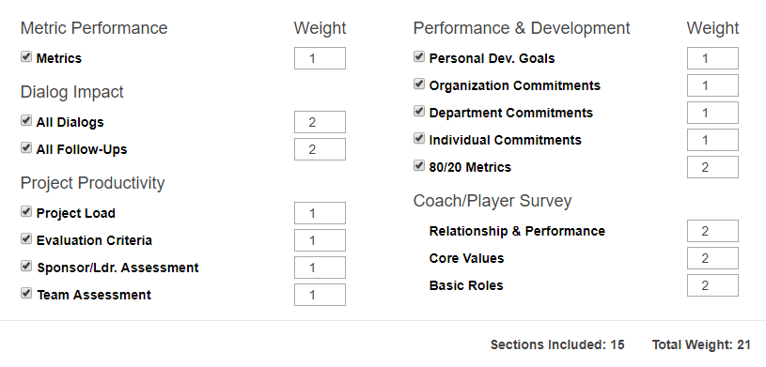

The general formula to get a weighted average or weighted mean is the sum of each score (from 1 to 5) multiplied by its weight, divided by the sum of all the weights.

Using the weights from the example above a sample individual has a 4.2 on their metrics for the period, 4.0 for individual dialogs, 2.8 for follow-ups and 5 for personal development goals. Since these are the only things they have for the period the rest are ignored. The overall score for their individual performance report would be:

Metrics (4.2 x 1 + Ind. Dialogs 4.0 x 2 + Ind. Follow-Ups 2.8 x 2 + Personal Dev. Goals 5 x 1) / Total Weight 6 = Weighted Avg **3.8**

**Performance Evaluation Surveys**

This area is where the coach/player individual performance evaluation surveys are sent to the individuals. [more information about what this survey is about]. A pair of performance evaluation surveys are sent for each individual selected in the dashboard settings. One survey goes to the selected individual, the player, and the other goes to their coach.

The column on the right shows when the player last received an evaluation survey. If you enter the name of a department or individual in the filter at the top it will narrow down the list to only those the entered text matches or is a part of. The filter does not eliminate individuals that are already selected to receive a survey though.

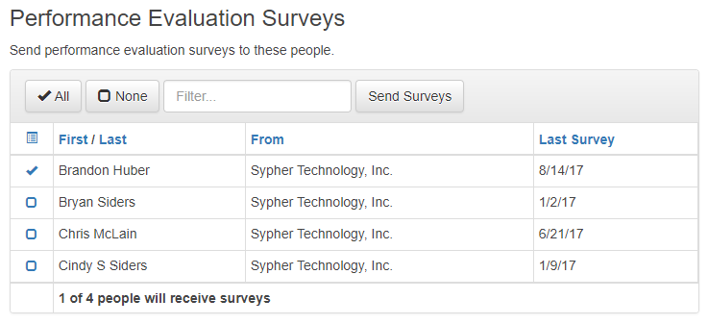

When you have selected whom to send survey(s) just use the Send Surveys button and pick which period to send the survey for and how many days they will have to finish the survey process. The player will receive an email notifying them that there is a survey to fill out. If a survey is sent for a previous period it will be set as the last/most recent survey. Only the last survey for a period is considered in the individual performance report.

All surveys will still be visible in the owner’s survey list, which is accessible from the Surveys link in the Performance Management area in the application. The surveys page lists all current and past surveys for the logged in individual. It will also show when your survey is under review if you are waiting to get it back.



The surveys in Connections Online use a 1 to 5 rating scale. When sending the surveys, you also select how many days until they are due. This includes the entire survey process from player filling out their self-evaluation, the coach completing their evaluation of the player and any reviews that need to be made along the way.

Example: Core Values in the Coach/Player Performance Evaluation Survey.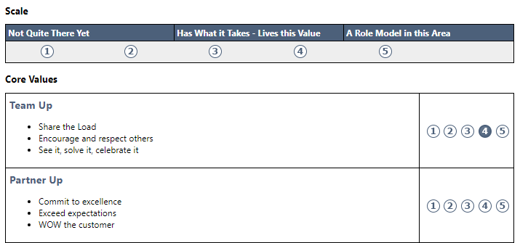

The three scored sections of the performance evaluation survey, Relationship and Performance, Core Values and Basic Roles, were listed in the period settings under Coach/Player Settings. Each appears on the individual performance report with separate weighting options.

The surveys can be sent at any time during the period and the individual performance report will use the most recent/last of the surveys toward their overall score. Surveys can be sent in the middle of a period to let employees know how they are doing so far and what they can improve to get a better score on the next survey in the period. The only restriction on sending these surveys is that an individual can only receive one of them a day.

**Core Values**

Core Values are not set on a period basis and are organization-wide. These are the organization’s ideals that everyone in expected to uphold and will be scored on in their performance evaluation survey. This list must be at least one item but can be as many as needed. Each of these core values will be an item that is scored on a one to five scale in the individual performance evaluation survey for the period.

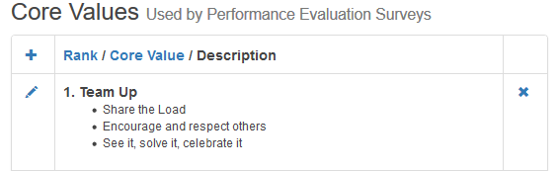

***ORGANIZATION DASHBOARD***

**Organization Metric Performance Dashboard**

The Metric Performance Dashboard provides a summary/composite of the metrics for the Organization currently being viewed. Metrics can belong to multiple periods because the values they track are inputted as long as the data is relevant to your organization.

In the top metric dashboard (i.e. Organization Metrics), you can click on any of the percentages and a detailed grid will show detail of the metrics that create that percentage.

Metric Calculation Example: This organization has three metrics at or exceeding expectations, two metrics meeting expectations, another two in the minimum range and four metrics below minimum. With a total of 11 metrics that have values recorded for this period the image below displays what you would see in the dashboard.

Exceeds: 3 / 11 = 27% Meets: 2 / 11 = 18% Minimum: 2 / 11 = 18% Below: 4 / 11 = 36%

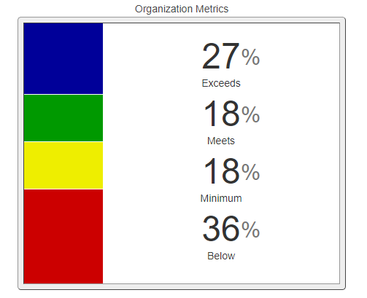

**Organization Project Productivity Dashboard**

The Project Productivity Dashboard shows how many projects are currently on the list of “current” projects for the Organization being viewed. These projects MUST have an Actual Start date as well as a Projected or Actual End Date -- if the project lacks either one of these fields being completed, the project summary information will not include that project in this dashboard.

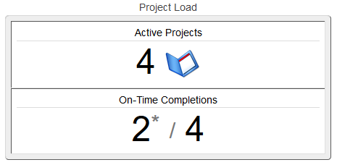

When you click on the Project Load dashboard, you will see the detailed information summarized in this view. The detailed project view is only for this Organization.

You will see a ratio under the list of active projects, these two numbers are as follows: # projects completed on time / total # of projects completed. There is a ratio both for the Organization and also for Departments that are subordinate to this Organization. An asterisk indicates the projected end date has changed for at least one of the projects.

Composite Project Team Assessments is a summary of the surveys that are sent immediately after a project for that Organization that has added an “Actual End Date”. If you click on this dashboard, you will see a more detailed grid of information regarding the surveys of completed projects for that Organization.

**Organization Dialog Impact Dashboard**

The Dialog Impact Dashboard is a summary/composite of Dialogs and All Dialog Follow-ups for the Organization/Department/Projects/Individuals associated with the specific Organization.

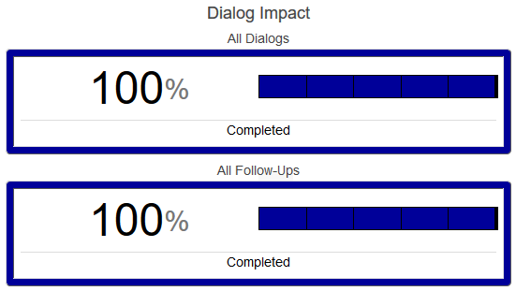

An organization is expected to hold one dialog per month during a performance period. If a hire date is set for an individual, they will not be expected to have dialogs in the period before they were hired. Clicking onto the Dialog Dashboard provides more Dialog detail.

For all Dialog Follow-ups, a minimum of one Dialog Follow-up per Dialog (for every Dialog) must be entered to appear in the summary. Also, follow-up tasks can span two periods. In order to not penalize the organization or its members for a follow-up task that is not due until next period, it will count toward the period the end date falls in.

**Organization Performance & Development Dashboard**

The Personal Development Goals Dashboard shows the summary of completion percentage of Personal Development Goals that have been entered / updated in the Personal & Development Goals module of the Individual Tabs for individuals who are subordinate to the organization.

The Organization Completed Commitments Dashboard is derived from the module on the Organization page that is currently being viewed, entitled “Organization Commitments”.

Clicking on the Completed Commitments Dashboard will show detail of Organization commitments in grid format, including names and due dates. In addition, completed commitments will also show for Department and Individuals subordinate to the Organization.

There is also an 80/20 Metrics at Target Or Better Dashboard. This is a summary/composite of the metrics that the Organization feels are the most important on the list of metrics.

This dashboard shows the summary/composite of the metrics on the Organization tab that have been checked as the “most important” of the metrics on the list of metrics.

To indicate a metric as an “80/20 Metric”, open the metric in the Organization to view as a single metric page. Click the pencil in the upper left corner on the image indicating a metric, and you will see the metric edit view. Check the box next to “80/20 Metric” and click update.

The 80/20 calculation isn't an average, it is a percentage of the metrics that are at target or better, therefore Meets or Exceeds.

***DEPARTMENT DASHBOARD***

**Department Metric Performance Dashboard**

The Metric Performance Dashboard provides a summary/composite of the metrics for the Department currently being viewed. Metrics can belong to multiple periods because new values will be entered as long as the data is relevant to the Department.

In the top metric dashboard (i.e. Department Metrics), you can click on any of the percentages and a detailed grid will show detail of metrics that create that percentage.

Metric Calculation Example: With one metric at or exceeding expectations, three metrics meeting expectations, another two in the minimum range and three metrics below minimum threshold this is the dashboard display.

Exceeds: 1 / 9 = 11% Meets: 3 / 9 = 33% Minimum: 2 / 9 = 22% Below: 3 / 9 = 33%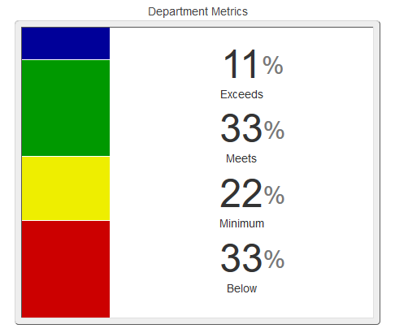

**Department Project Productivity Dashboard**

The Project Productivity Dashboard shows how many projects are currently on the list of “current” projects for the Department being viewed. These projects MUST have an Actual Start Date as well as a Projected End Date -- if the project lacks either one of these fields being completed, the project summary information will not include that project in this dashboard. An asterisk indicates the projected end date has changed for at least one of the projects.



When you click on the Project Load dashboard, you will see the detailed information summarized in this view. The detailed view will be for this Department only.

You will see a ratio under the list of active projects, these two numbers are as follows: # projects completed on time / total # of projects completed. An asterisk indicates the projected end date has changed for at least one of the projects.

Composite Project Team Assessments is a summary of the surveys that are sent immediately after a project for that Department that has added an “Actual end date”. If you click on this dashboard, you will see a more detailed grid of information regarding the surveys of completed projects for that Department.

**Department Dialog Impact Dashboard**

The Dialog Impact Dashboard is a summary/composite of Dialogs and All Dialog Follow-ups for the Department/Projects/Individuals associated with the specific Department.



A department is expected to hold one dialog per month during a performance period. If a hire date is set for an individual, they will not be expected to have dialogs in the period before they were hired. Clicking onto the Dialog Dashboard provides more Dialog detail.

For all Dialog Follow-ups, a minimum of one Dialog Follow-up per Dialog (for every Dialog) must be entered to appear in the summary. Also, follow-up tasks can span two periods. In order to not penalize the organization or its members for a follow-up task that is not due until next period, it will count toward the period the end date falls in.

**Department Performance & Development Dashboard**

The Personal Development Goals Dashboard shows the summary of completion percentage of Personal Development Goals that have been entered / updated in the Personal & Development Goals module of the Individual Tabs for individuals who are subordinate to the Department.

The Department Completed Commitments Dashboard is derived from the module on the Department page that is currently being viewed, entitled “Department Commitments”.

Clicking on the Completed Commitments Dashboard will show detail of Department commitments in grid format, including names and due dates. In addition, completed commitments will also show for Individuals subordinate to the Department.

There is also an 80/20 Metrics At Target Or Better Dashboard. This is a summary/composite of the metrics that the Department feels are the most important on the list of metrics.

This dashboard shows the summary/composite of the metrics on the Department tab that have been checked as the “most important” of the metrics on the list of metrics.

To indicate a metric as an “80/20 Metric”, open the metric in the Department to view as a single metric page. Click the pencil in the upper left corner on the image indicating a metric, and you will see the metric edit view. Check the box next to “80/20 Metric” and click update.

The 80/20 calculation isn't an average, it is a percentage of the metrics that are at target or better, therefore Meets or Exceeds.

***INDIVIDUAL DASHBOARD***

**Individual Metric Performance Dashboard**

The Metric Performance Dashboard provides a summary/composite of the metrics for the Individual. These metrics may be represented in multiple periods if there are values entered in more than just one.

In the top metric dashboard (i.e. Individual Metrics), you can click on any of the percentages and a detailed grid will show detail of metrics that create that percentage. These are metrics for the Individual’s own job.

Metric Calculation Example: With one metric at or exceeding expectations, two metrics meeting expectations, another two in the minimum range and one metric below minimum this is the distribution of individual metrics.

Exceeds: 1 / 6 = 17% Meets: 2 / 6 = 33% Minimum: 2 / 6 = 33% Below: 1 / 6 = 17%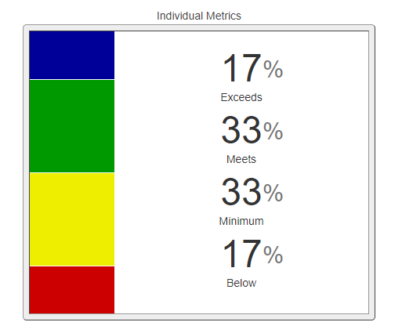

**Individual Project Productivity Dashboard**

The Project Productivity Dashboard shows how many projects are currently on the list of “current” projects for the Individual being viewed. These projects MUST have an Actual Start date as well as a Projected End date -- if the project lacks either one of these fields being completed, the project summary information will not include that project in this dashboard.



When you click on the Project Load dashboard, you will see the detailed information summarized in this view. The detailed view of projects will be where this Individual is one on the project team.

You will see a ratio under the list of active projects, these two numbers are as follows: # projects completed on time / total # of projects completed. An asterisk indicates the projected end date has changed for at least one of the projects.

Composite Project Team Assessments is a summary of the surveys that are sent immediately after a project for which that Individual is a Sponsor/Leader/Member that has added an “Actual end date”. If you click on this dashboard, you will see a more detailed grid of information regarding the surveys of completed projects for that Individual.

**Individual Dialog Impact Dashboard**

The Dialog Impact Dashboard is a summary/composite of Dialogs and All Dialog Follow-ups for the Department/Projects associated with the specific Individual.



An individual is expected to hold one dialog per month during a performance period. However, if a hire date is set for an individual, they will not be expected to have dialogs in the period before they were hired. Clicking onto the Dialog Dashboard provides more Dialog detail.

For all Dialog Follow-ups, a minimum of one Dialog Follow-up per Dialog (for every Dialog) must be entered to appear in the summary. Also, follow-up tasks can span two periods. In order to not penalize the organization or its members for a follow-up task that is not due until next period, it will count toward the period the end date falls in.

**Individual Performance & Development Dashboard**

The Task Overview Dashboard shows the number of open, overdue, completed and upcoming tasks for the specific individual. The amount in red is overdue tasks for the individual. In the details view the individual’s actual and projected hours are listed as well as start and end dates for each task. This section is useful for coaches or players to quickly identify what is on the individual’s plate at the moment and what they have accomplished so far. This section is only featured on the individual dashboard.

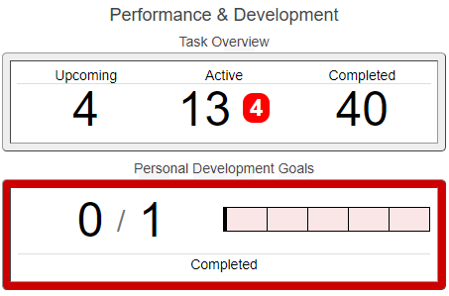

The details page for the Task Overview Dashboard lists all tasks for this period and by default sorts them by ascending due date. The tasks can be sorted by any column by clicking on the blue title at the top.

The Personal Development Goals Dashboard shows the summary of completion percentage of Personal Development Goals that have been entered / updated in the Personal & Development Goals module of the Individual Tab for the specific individual.

The Completed Commitments Dashboard is derived from the module on the Individual’s page that is currently being viewed, entitled “Individual Commitments”.

Clicking on the Completed Commitments Dashboard will show detail of Individual commitments in grid format, including names and due dates.

There is also an 80/20 Metrics At Target Or Better Dashboard. This is a summary/composite of the metrics that the Individual feels are the most important on the list of metrics.

This dashboard shows the summary/composite of the metrics on the Individual tab that have been checked as the “most important” of the metrics on the list of metrics.

To indicate a metric as an “80/20 Metric”, open the metric in the Individual Tab to view as a single metric page. Click the pencil in the upper left corner on the image indicating a metric, and you will see the metric edit view. Check the box next to “80/20 Metric” and click update.

The 80/20 calculation isn't an average, it is a percentage of the metrics that are at target or better, therefore Meets or Exceeds.

***PROJECT CLOSEOUT SURVEYS***

The project must have a Sponsor and a Leader or Member. Also, the project needs to have an actual end date set before the surveys can be sent. When the previous conditions are met the Send Surveys button will appear. This button is used to send the Project Team Survey and Project Leader/Sponsor Survey.

After they are sent, the survey button will send email reminders to finish the survey to those who have not. The number of completed surveys and the number of total surveys sent will also be listed to the right side of the survey reminder button.

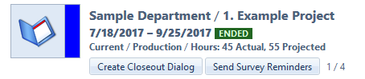

Any person on the project team can be included in the project team survey. Project Leaders and Members are automatically included in the team survey when added to the project. It is usually the case that they will be doing most of the day-to-day work on the project. The recipients of the project team survey can be changed at any time *before* the surveys are sent, by using the Team Survey checkbox in the Team Member module. Only Site Administrators and the Project Leader are able to see and change who is included in the project survey.

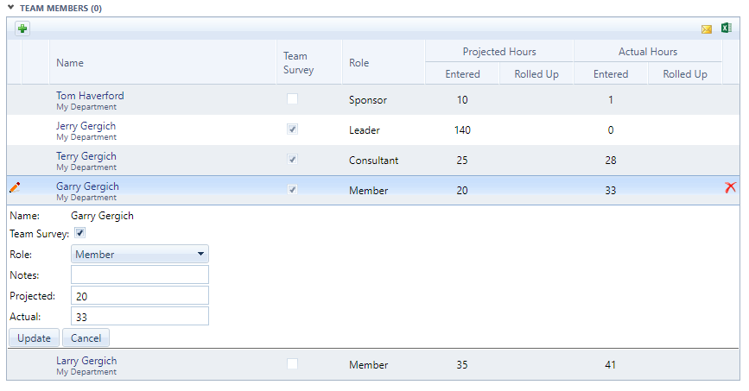

In the above case Jerry, Terry and Garry will receive project team surveys at the end of the project. Tom will receive the Leader/Sponsor survey. Normally Larry would be included in the team survey as a Project Member but for some reason Jerry, the Project Leader, decided to not have him take it.

***Project Team Survey***

Each team member will be asked to rate themselves and each other person who received a project team survey. The example below demonstrates the layout of the survey and the criteria on which each person on the survey will be evaluated. 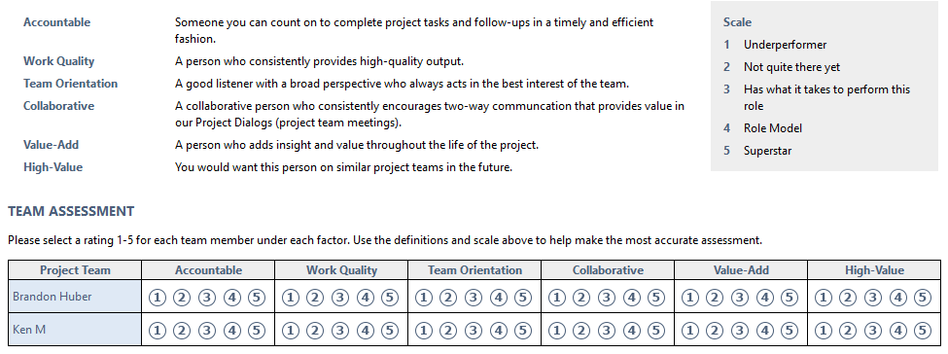

These ratings will appear in the Project Team Assessments Details if at least 3 people have given a score (to make it impossible to tell who rated what) otherwise N/A will be in the place of the average score the individual received.

The average score an individual receives from the project team survey will be added to their individual performance report. The TEAM column is the average scores received by all team members on all the project team surveys this individual has been a part of this period. The SELF column is the average score they have given themselves. The Score column is the average score this individual has been given by all other team members this period. The overall value from the Score column, 2.9 here, is what is incorporated in the individual performance score.

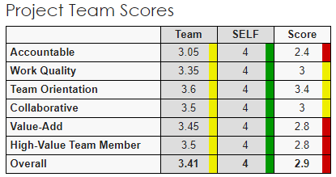

**Project Leader / Sponsor Survey**

This survey consists of questions about how well the project was kept on track and whether it achieved the expected result. This survey is sent to a Project Sponsor to be filled out with input from all Sponsors and Leaders on the project.

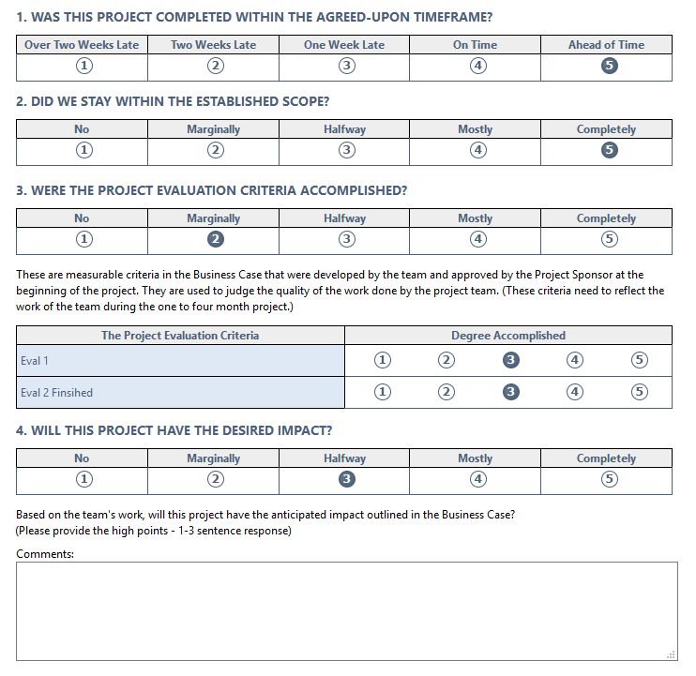

The survey results and comments are then added to the project closeout dialog in order to wrap up the process and reflect on lessons learned. Project Leaders will have the scores from this survey included in their individual performance report.

***COACH / PLAYER PERFORMANCE EVALUATION SURVEY***

There are four sections to the performance evaluation survey. Each of these will be filled out once by the player and then by the coach afterward. This survey will be used periodically during the year to more formally measure how well the Player is performing their role. It also provides insight on the Coach's overall guidance.

**The Player**

The first section is **Relationship and Performance** where the player evaluates themselves in 8 categories which are displayed below. These mostly focus on company culture, the relationship between the player and coach and some other soft skills.

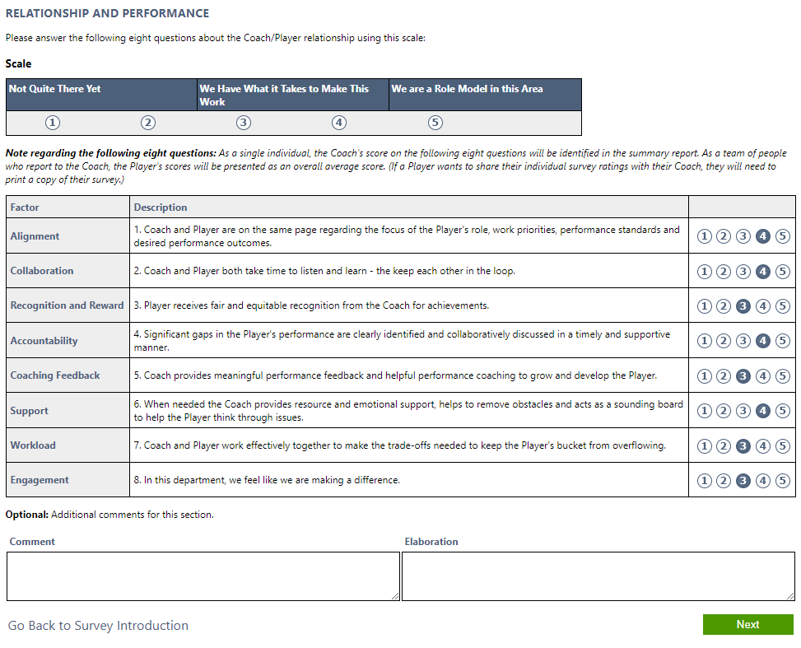

The comments at the bottom are optional, but can be useful when you want to elaborate on one of the ratings above or give additional feedback about something related to Relationship and Performance.

**Core Values**

The second part of the evaluation covers the organization’s **Core Values,** which werepreviously entered in the dashboard settings. Much like the previous section each is scored on a 1 to 5 scale and there is an optional comment area if the player or coach has additional comments or feedback to give.

In the example below the coach is able to see what score the player had given themselves as well as the comment about their rating decision. The player’s scores and comments are the ones with the green background.

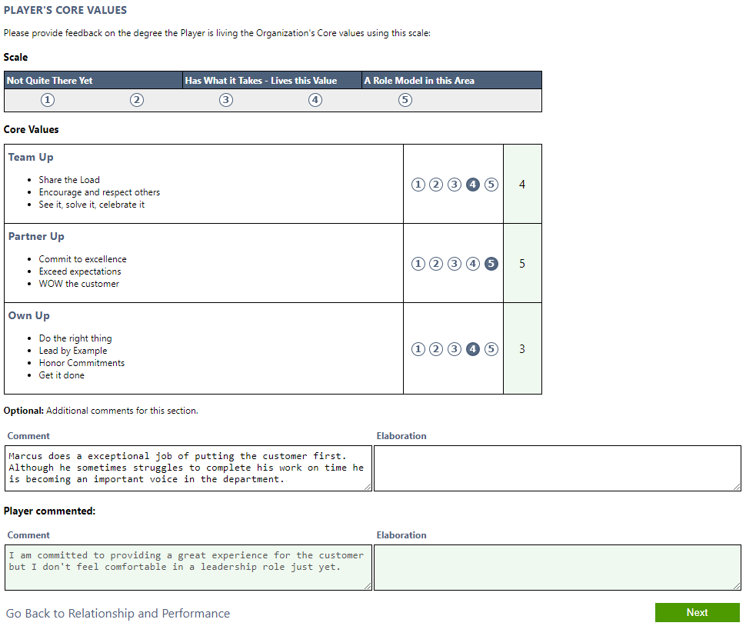

The third section covers the player’s **Basic Roles**. Each of these are qualitative/quantitative actions or goals the individual carries out in order to help carry out the overall organization strategy.

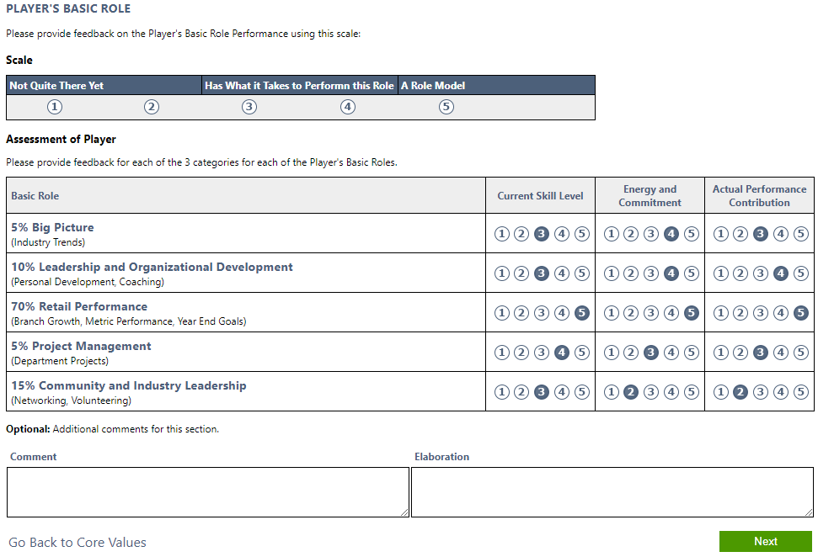

The last portion of the performance evaluation survey is where the player states what makes them good at their job and what areas they may need to work on. The coach will then offer their input when they fill out the survey afterward. The player’s comments will be visible with the green background like in the core values example.

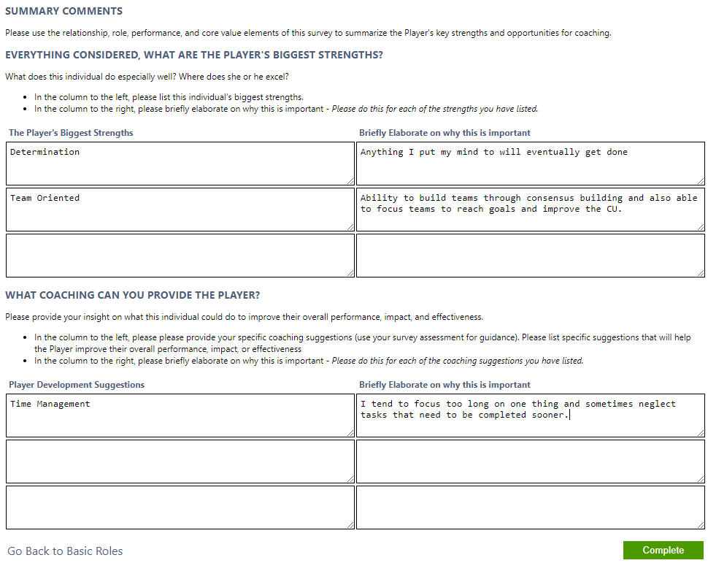

When all parts of the survey have been filled out it will be sent to the coach for their review of how the player evaluated themselves. The coach receives an email notification that they are now able to fill out their portion of the survey as soon as the player clicks complete.

**The Coach**

The coach will follow the same process the player did. The Relationship and Performance, Core Values and Basic Roles sections will show the player’s ratings. If the player added any comments they will also be there for the coach to see on the section they belong. The player’s self-evaluation may help the coach decide what score to give. The coach can give comments as they go through the survey as well. If there is a discrepancy between what the coach scored and what the player scored it may be useful to include a comment as to why the coach gave that score.

On the fourth page, the coach will see the player’s strengths and areas that need coaching/improvement. The coach then fills out this section on the player. This includes as much feedback possible in order to steer the player in the best direction to improve themselves or empower/recognize a great employee.

After the coach is finished filling out the survey they will have the option to either send it back to the player for their final approval or send it to someone else in the organization to review the survey. Maybe there is another person in the department that can give feedback or approval on what the coach scored or commented? Also, it could go to someone in human resources to ensure the coach does not say something inappropriate or get themselves in trouble. If there is an open review the coach will not have the option to send the survey back to the player.

The review process is controlled by the coach. The coach can select one reviewer at a time to look over the pair of surveys and either approve or disapprove of what they see. When all reviewers have approved the coach will be notified via email and given the option to send the survey to the player for final approval or continue the review process.

**Reviewer**

The reviewer is given access to the survey summary which has all the contents of the survey on one page. They can see the ratings and comments from both the coach and player. After looking over the survey the reviewer can add comments about changes that need to be made to the survey before they can approve of sending it to the player.

The coach then receives an email detailing whether the reviewer approved or disapproved of the survey as it was when it was sent to them. The details of their disapproval are in the comments at the top of the strengths and coaching page. The reviewer comments in this area can only be seen by the coach and the reviewer who made the comments. There can be any number of

When the survey is sent to the player for final approval they will get the opportunity to look over a summary of both surveys combined and give their final approval, closing the survey for further input.

**Individual Performance Report**

The individual performance report is a culmination of the individual’s efforts in Connections Online during a single performance period. The report will display the scores and showing how they have done in every applicable aspect in Connections Online during a single period. Deleted items will not be factored into any of the calculations for this report. Only tasks/projects/surveys etc. that were for the selected period will be evaluated.

Values in this report are all from a scale of 1 to 5, with 1 being poor and 5 being excellent. Values from surveys are already in this scale. Any other values are multiplied by 4 and then added to 1 in order to put it in the 1 to 5 value range. With 9 completed individual commitments of 9 total for the period, this value becomes a 1. Then 1*4 = 4. 4+1 = 5 for the full value.

For items where you have more completed than the projected value such as 7/6 dialogs completed for the period it will not count for extra credit in the overall calculation. If a department has completed 6/6 dialogs and both department members have completed 3/6 and 8/6 dialogs the total will be 15/18 and not 17/18.

**Overall Score –** This score is reflective of the individual’s overall performance for the selected period. The items below are what is used to calculate this overall value. Not every individual will have values for all of the items on the list. Some things like Department Dialogs may not appear or be scored because the individual is not a department leader. Anything not on this list is just for reference.

* Metrics
* Metrics 80/20
* Project Evaluation Criteria (Project Leader and Members)
* Project Leader Assessment (Project Leader and Members)
* Project Team Assessment (Anyone on a Project Team Survey)
* Individual Dialogs
* Personal Development Goals
* Department Dialogs (Department Leader only)
* Department Metrics (Department Leader only)
* Department Metrics 80/20 (Department Leader only)
* Department Commitments (Department Leader only)
* Overall Performance & Development (Coach)
* Overall Basic Roles (Coach)
* Overall Core Values (Coach)

**Where the values come from:**

**Metrics –** The number of all metrics that meet expectations, including 80/20, divided by the total number of metrics in the specified period where the individual is the owner. This value is multiplied by 4 and then added to 1 to fit in the 1-5 scale.

**80/20 Metrics –** The number of 80/20 metrics that meet expectations divided by the total number of 80/20 metrics in the specified period where the individual is the owner. This value is multiplied by 4 and then added to 1 to fit in the 1-5 scale.

**Project Evaluation Criteria –** Averaged evaluation criteria ratings for completed projects this period where the individual was a team leader or member. Values entered are already in the 1-5 scale.

**Project Leader Assessment –** Is the total average score for all of the items in the Project Leader/Sponsor Scores area. Those values are the average scores for all projects where the individual was a leader or member for the given period. The survey values are already in the 1-5 scale.

**Project Team Assessment -** In the project team scores table this is the score column. Each of these values is the average score given for the individual by other team members on projects during the current period. The survey values are already in the 1-5 scale.

**Individual Dialogs –** The number of individual dialogs that occurred divided by the number of expected dialogs this period for the current individual. This value is multiplied by 4 and then added to 1 to fit in the 1-5 scale.

**Project Dialogs –** The number of project dialogs occurred divided by the number of expected dialogs for the period where the individual was either a leader or member. Any amount of occurred that is greater than the expected amount will be ignored for calculation. This value is multiplied by 4 and then added to 1 to fit in the 1-5 scale.

**Dialog Follow-ups –** Project dialog follow-up tasks where the individual was either the leader or member, individual dialog follow-up tasks and primary department dialog follow-up tasks, if they are the leader. All of which were created in the current period and the average of the number completed / total is adjusted for the 5-point scale.

**Individual Commitments –** The number of completed commitments divided by total commitments for this period for this individual. This value is multiplied by 4 and then added to 1 to fit in the 1-5 scale.

**Personal Development Goals –** Totalcompleted personal development goals divided by total goals for this period. This value is multiplied by 4 and then added to 1 to fit in the 1-5 scale.

**Department Dialogs –** Completed department dialogs where the individual is a department leader divided by expected department dialogs for the selected period. This value is multiplied by 4 and then added to 1 to fit in the 1-5 scale.

**Department Metrics –** The number of department metrics that meet expectations, where the individual is the department leader, divided by all department metrics, 80/20 included, for the selected period. This value is multiplied by 4 and then added to 1 to fit in the 1-5 scale.

**Department Metrics 80/20 –** The number of department 80/20 metrics that meet expectations, where the individual is the department leader, divided by all department 80/20 metrics for the selected period. This value is multiplied by 4 and then added to 1 to fit in the 1-5 scale.

**Department Commitments –** Each department commitment that is completed is given a score of 5. The commitments that are not yet completed receive a 1. The score of this section is the average of all these department commitment scores for this period.

**Relationship & Performance, Core Values and Basic Roles -** These are the three sections of the performance evaluations survey. Each section uses the average of the coach's scores that are individually added into the overall performance score.

**Project Leader / Sponsor Scores**

Average overall assessment scores for all projects where you were a leader or member for the given period. These values are already entered in the 1-5 score format. The following are averaged and represented under the Project Leader Assessment area so the individual values here are just for reference.

**Completed on Time –** The sum ratings for being completed on time / #total for projects this period.

**Evaluation Criteria Accomplished –** The sum evaluation criteria rating / total amount of entries this period

**Desired Impact –** The sum of desired impact ratings / #total for this period

**Within Scope –** The sum on scope ratings / #total for projects this period.

**Project Team Scores**

**\* TEAM Column –** These are the average overall assessment scores for all completed projects for the given period if there were more than 2 values. The values in this column are for reference only. They do not affect your overall score.

**\* SELF Column –** This is the average of your self-evaluations on completed projects this period where you were a leader or member. Minimum of 3 values are required to display score. The values here are for reference only. They do not affect your overall score.

**Score Column –** Here are the values that your other team members scored you for the completed projects this period. This includes instances where the you were a leader or member. There must have been at least 3 responses for the average value to display. These values are averaged and that value contributes toward the overall score.

**Performance Survey**

**\* Player Column** **–** This column lists the values the individual gave themselves a score 1 to 5, 5 being the best possible, for each of their core values, relationship & performance items as well as their basic roles.

**Coach Column –** This column lists the coach’s scores for the individual on each of the same items. Only the coach’s scores will be represented in the overall individual performance score. Core Values, Relationship and Performance each have their overall score averaged into the overall score for the report.